Programming Fundamentals Lab 8 Outputs

Name: Saahil Ghulam

Roll Number: 24K-0570

Section: BCS-1D

Q1: 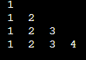

Q2: 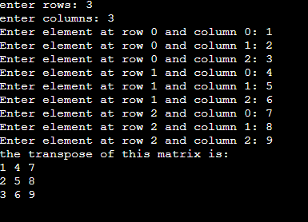

Q3: 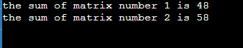

More Problems

Q1: 

Q2: 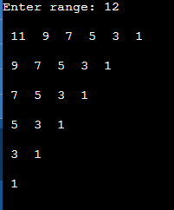

Q3: 

Q4: 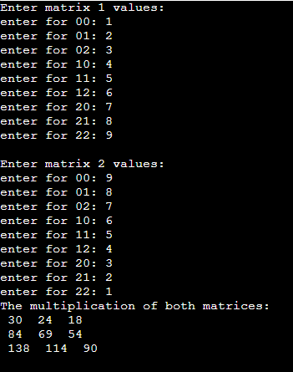

Q5: 